Shaping our digital future with the first EU Open Data Days

The first ever EU Open Data Days took place online from 23 to 25 November 2021. The event comprised EU DataViz, an international conference on open data and data visualisation, followed by the finals of EU Datathon, the annual open data competition.

The EU Open Data Days were designed to be relevant to all open data stakeholders and data reusers, with a special emphasis on the needs of the EU´s public sector. The event attracted well over 2.000 registrations from data enthusiasts, data visualisation experts and solution-seekers. On the stage, different sectors of the society were represented, with speakers bringing their experience from public administrations, universities and international organisations such as the World Bank.

The EU Open Data Days were opened by Hilde Hardeman, the newly appointed Director-General of the Publications Office, and showcased several high-profile keynote speakers. Xavier Bettel, Prime Minister of Luxembourg, highlighted the priority that the government of Luxembourg gave to digital transformation, and Johannes Hahn, European Commissioner for Budget and Administration, provided the context for the Commission´s vision of digital transformation of the EU by 2030. Inspiring remarks about the future of open data were delivered by Boštjan Koritnik, Minister of Public Administration of Slovenia, representing the Slovenian Presidency of the Council of the European Union, and Pascal Leardini, Deputy-Secretary-General and Chief Operating Officer of the European Commission.

EU DataViz 2021 (23 – 24 November 2021)

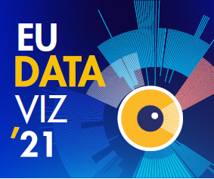
The EU Open Data Days started with the EU DataViz 2021 conference, aimed at sharing experience and best practices related to open data and data visualisation. Day 1 explored open data as a key enabler of digital transformation. In a plenary session, Yvo Volman from the European Commission presented the EU perspective on open data and detailed its plans for building a single European market for data. Specialised sessions addressed topics ranging from the interoperability and accessibility of EU open data to the creation of open data ecosystems and a lot more.

Day 2 centred on data visualisation. Sixtine Bouygues from the European Commission, highlighted the benefits and challenges of data visualisation for the EU administration, and Valérie Saintot from the European Central Bank focused on data visualisation as a vector of innovation. Break-up sessions inspired discussions about data visualisation as a tool for discovering new knowledge through storytelling, and explored internationally successful data visualisation projects, together with the latest trends in the field.

EU Datathon (25 November 2021)
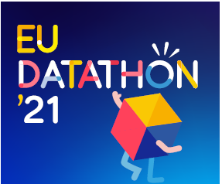
The EU Open Data Days closed with the finals of EU Datathon, the annual EU open data competition. Nine finalist teams, selected from almost 100 submissions coming from 33 countries, competed in three categories, aligned with the European Commission’s political priorities.

Prior to the finals, the teams presented their ideas for apps built on EU open data in a series of videos. On 25 November 2021, they pitched the fully functioning apps to the jury and the audience. Up for grabs was the prize fund of EUR 99 000, together with the Public Choice Award. In his keynote speech, Commissioner Johannes Hahn praised the teams´ innovative approaches and solutions to help Europe address its key challenges: ‘Moving forward, is not solely constrained by a lack of technology, but often by a lack of an appropriate mindset... You have created meaningful new projects and developed functioning applications to address crucial challenges.’

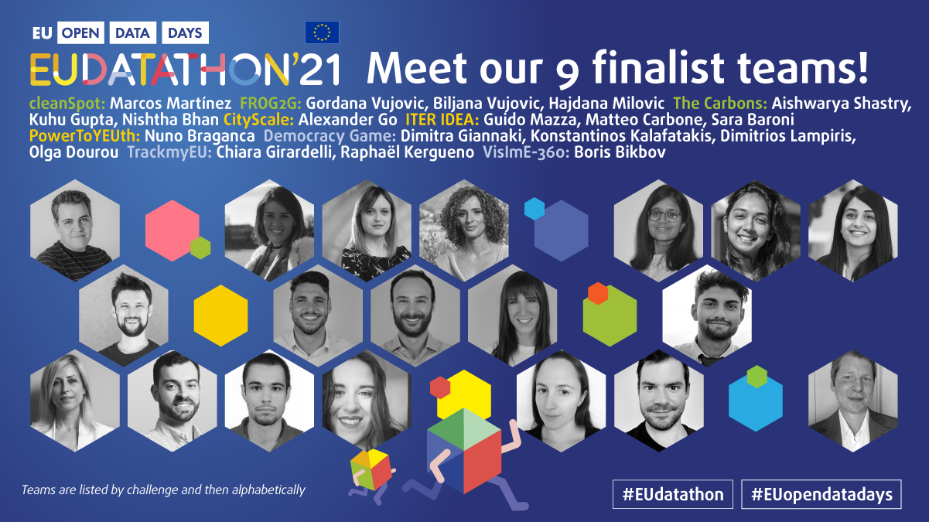

A jury of 18 data specialists chaired by Per Nymand-Andersen (European Central Bank) selected the winners for each challenge.

The winners of challenge 1: A European Green Deal
1st place: The Carbons – Fuel your body without fouling the Earth. (India)
2nd place: cleanSpot – Boost recycling because there is no planet B. (Spain)
3rd place: FROG2G – Turn your city from grey to green, one tree at a time. (Montenegro)

The winners of challenge 2: An economy that works for people
1st place: ITER IDEA – A new portal facilitating women’s mobility in Europe. (Italy)
2nd place: PowerToYEUth – Find public funding for your SME, and boost youth employment. (Portugal)
3rd place: CityScale – Visualise, compare and find the best place for you to live. (Ukraine)

The winners of challenge 3: A Europe fit for the digital age
1st place: TrackmyEU – Explore EU policies, track your interests, and make your voice heard in Brussels! (France, Italy)
2nd place: Democracy Game – Try your hand at politics with a virtual debating tool. (Greece)
3rd place: VislmE-360: Get a 360ᵒ view of vision impairment in the EU. (Italy)

Public Choice award
The Public Choice Award was bestowed on the following teams:
1st place: ITER IDEA (Italy)
2nd place: cleanSpot (Spain)
3rd place: FROG2G (Montenegro)

The EU Open Data Days were organised by the Publications Office of the European Union, with the active support of over 60 partners, representing the data providers from EU institutions and agencies, European national open data portal and national statistical offices, and key digital players in Luxembourg.

