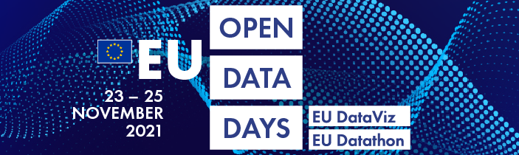
Book your place at the EU Open Data Days

The first ever EU Open Data Days, launched in March 2021, are gathering steam. This unique event will take place fully online from 23 to 25 November and is now opening for the registration of participants. Book your place soon! The EU Open Data Days are free and open for everyone to attend.
Setting out with the aim of ‘shaping our digital future with open data’, the EU Open Data Days will highlight the benefits of open data, its visualisation and its reuse for the EU public sector, citizens and businesses. The event’s rich programme is designed to benefit a broad audience, including experts, open data enthusiasts and the public.

Explore the world of open data
The EU Open Data Days will feature EU DataViz, a conference on open data and data visualisation for public administrations, from 23 to 24 November, and EU Datathon, the annual EU open data competition, on 25 November. The preparations have already passed several milestones. The call for proposals for both parts of the event closed on 21 May and resulted in 247 proposals received from 47 countries. The best of these proposals have been integrated into the programme of the EU DataViz conference and resulted in the selection of nine EU Datathon finalist teams who will pitch their apps in the competition finals.

Register and start networking
In addition to providing a forum for exchanging ideas, experience and best practices related to open data and its visualisation, the EU Open Data Days aim to build bridges between public administration, academia, the public sector and civil society, all of which will be represented. In addition, registered participants will benefit from a dedicated networking platform, opening this autumn, intended to inspire creative dialogue prior to the event and after it. Register for the EU Open Data Days and become part of the EU open data community.

Follow us for more information
The EU Open Data Days are organised by the Publications Office of the European Union with the support of the ISA² programme of the European Commission. More information is available on the EU Open Data Days website, or you can follow updates on Twitter @EU_opendata with the hashtag #EUopendatadays.

